PITCHCOMBE PARISH COUNCIL
ANNUAL MEETING OF THE COUNCIL
HELD AT 7.00PM ON 26th May 2022
IN THE VILLAGE HALL
Welcome and introductions –
Election of Chairman – nomination/seconded of Cllr Philippa James followed by signing of acceptance of office papers
Election of Vice-Chairman was carried forward to next
Attendance recorded as Parish Councillors Phillipa James (chair), Nigel Shaw, Beverley Gorton and Richard Pearson
Council recorded apologies for absence received from District Councillor Job (attended at 19.50), County Councillor Williams, Parish Councillor Jamie Cross
Declaration of Interest for matters on the agenda were invited- none
Minutes of the previous Parish Council Meeting held on 24TH March 2022 were approved
Council agreed to continuation delegation to Clerk of authority to make submission of comments on planning matters where no meeting of the Council is able to be held
Council considered if changes are required to standing orders or financial regulations – carry forward until model standing orders are published later in this year
Council considered if any changes are required to its Complaints, Freedom of Information or Data protection policies procedure -carry forward until model standing orders are published later in this year
Council considered dissipation of information to the wider community and agreed to use “pitchcombe net” and a list of dates to be put on the notice boards
Council agreed changes are required to the asset register – 4 notice boards, 2 bus shelters, laptop , telephone box, ( new values/nominal values)
Council reviewed representation on outside organisations - none
Council considered if any changes are required to insurance policy for the coming year- Clerk to check that individual items on asset register are covered
Council considered if any changes are required to the banking mandate - none
Council approved its independent internal auditor – as last year
Council agreed it wishes to renew its subscription/contracts to GAPTC, PATA Payroll etc
Council approved the financial reports and payment list as attached
Council approved its AGAR completion and delegated to the Chair of Council to sign the appropriate forms
Council agreed that its meeting schedule shall be as 4th Thursday of May, 28th July, September, November, January, March commencing at 7.30pm
Public Participation was invited – member of the public spoke regarding Lurks Lane, -He has been advised that the road can be adopted by GCC but will need to be in good condition. Some home owners have deeds that show they have responsibility but other home owners do not have this ownership in their deeds.
Further advice is being sought by owners from “ Devcoord” /Glos Highways (Highway Manager)
A public meeting may be called by residents and suggested that the Council chair such a meeting.
It was noted that the Council could not be responsible for the project, hold funds, or engage contractors. Council suggested that the resident could arrange a meeting of other residents to discuss this. Further suggestions included possible management company, arranging a holding account, insurance policies
Also suggested that the residents obtain a realistic quotation for the works

Council received update on Queen’s Platinum Jubilee
£430 raised by attic sale and bingo event
Road closures have been authorised
BBQ, music and children’s games have all been organised and then a cake will be cut – Saturday
Church service, Pimms in the churchyard and distribution of mugs to children will take place on Sunday
Any balance of funds will be donated back to the Village Hall
Report received from County Councillor distributed via email and will be attached to Parish Assembly minutes
Council noted new Speed Watch Safety fund has been launched to improve safety of county’s roads and considered the matter in relation to the main road The Council will continue to campaign for lower speed limits
Council received update on A46 junction and damaged bus shelter – carried forward pending update from the County Councillor. The Chair of the Parish Council will continue to lead on this matter. The bus shelter is secure. It was felt that the location of the bus shelter is vulnerable from speeding cars. The Council agreed not to make an insurance claim at this time.
Consideration given to a VAS but not carry forward
Chair to follow up with Police Commisisoner/County Councillor
Council received update on the signs, barriers and road cones which were left behind by Gigaclear after works on 21 March – now cleared
Report received from District Councillor Job and will be attached to the minutes of the Parish assembly
Council noted update on planning matters- following information distributed the Clerk and noted that:
22/0935/HHOLD- Barn View , Wragg Castle Lane, Council happy to support
22/0190/FUL Kellavie, Wragg Castle Lane,- SDC approved
Ref:S.22/0115/LBC Pitchcombe Mill, SDC approved

Close of meeting at 19.59

Payment list approved by Parish Council at May 22 meeting
PATA payroll £115.40
B Holder expenses £22.82
Community First (insurance)
HMRC £91.20 (April, May, June)
P. James reimbursement for jubilee plaque

Financial reports – year end March 2022
Cash book
01/04/21-31/03/2022 | CASH BOOK
payee | date | CHQ NO | AMOUNT | CURRENT A/C balance
opening current account balance |  |  |  | 1928.51
PRECEPT |  |  | 1625.00 | 3553.51
parish council websites | 09/04/2021 | 422 | 130.00 | 3423.51
I Crowe | 10/05/2021 | 423 | 25.00 | 3398.51
h paton | 10/05/2021 | 424 | 164.55 | 3233.96
h paton | 10/05/2021 | 425 | 164.55 | 3069.41
hmrc | 10/05/2021 | 426 | 67.60 | 3001.81
cancelled |  | 427 | 0.00 | 3001.81
community first | 18/06/2021 | 428 | 199.91 | 2801.90
h paton | 23/08/2021 | 429 | 164.55 | 2637.35
h paton | 23/08/2021 | 430 | 164.55 | 2472.80
h paton | 23/08/2021 | 431 | 164.55 | 2308.25
h paton | 23/08/2021 | 432 | 164.55 | 2143.70
hmrc | 23/08/2021 | 433 | 135.20 | 2008.50
b holder locum | 16/09/2021 | 434 | 239.82 | 1768.68
b hoder expenses | 16/09/2021 | 435 | 58.84 | 1709.84
k gristock notice board | 16/09/2021 | 436 | 60.05 | 1649.79
b gorton goodwill | 16/09/2021 | 437 | 7.00 | 1642.79
precept receipt | 04/10/2021 | rec | 1625.00 | 3267.79
b holder locum | 25/11/2021 | so | 146.00 | 3121.79
bholder locum | 25/12/2021 | so | 146.00 | 2975.79
bholder locum | 25/01/2022 | so | 146.00 | 2829.79
bholder locum | 25/02/2022 | so | 146.00 | 2683.79
bholder locum | 31/03/2022 | so | 146.00 | 2537.79
b holder expenes | 10/12/2021 | 438 | 18.32 | 2519.47
village hall hire oct | 08/12/2021 | 439 o/s | 28.00 | 2491.47
cancelled |  | 440 | 0.00 | 2491.47
b holder expenes | 17/03/2022 | 441 | 74.66 | 2416.81
cancelled |  | 442 | 0.00 | 2416.81
cancelled |  | 443 | 0.00 | 2416.81
village hall hire dec/march | 24/03/2022 | 444 o/s | 56.00 | 2360.81
b holder locum | 24/03/2022 | 445 | 167.97 | 2192.84
b gorton portaloos queens jubilee | 24/03/2022 | 446 | 90.00 | 2102.84

Bank reconciliation at 31/3/22

01/04/2021 | OPENING BANK BALANCE |  |  | 1928.51
 | EXPENDITURE FOR PERIOD |  | 3075.67
 | INCOME FOR PERIOD |  | 3250.00
 | NET EXPENDITURE
as at above | BANK BALANCE AS ABOVE |  |  | 2102.84
as at 28/3/22 | BAL PER S/M |  |  | 2186.84
 | LESS U/P CHEQUES
 |  | 444 o/s | 56.00
 |  | 439 | 28.00
 |  |  |  | 84.00
31/03/2022 | reconciled balance |  |  | 2102.84

Reserves – recommended to be split into earmarked/contingency/general and precept reserves (which should be at least 1 year of precept)

earmarked reserves |  |  | 2021 | 2022
Village improvements |  |  |  | 675
election costs
Bus shelter |  |  |  | 1000
contingency |  |  | 1929 | 428
 |  |  | 1929 | 2103
general
bank balance at year end |  |  | 1929 | 2103

PAYROLL RECONCILIATION – figures taken from HP spreadsheet – NO P11 on file

PAYE reconciliation |  | gross | hmrc | net
HP spreadsheet |  | £1,016.10 | 203.00 | 813.10
cash book |  | 1016.10 | 202.80 | 813.30

BH locum until 1/4/22

Year to date against budget

budget to date | BUDGET | ACUTAL YEAR TO DATE | BALANCE AVAILABLE TO SPEND
PRECEPT | 3250 | 3250
bank interest deposit account |  | 0
inter account trans |  | 0
wayleave |  | 0
VAT to be reclaimed |  | 0
other receipts |  | 0
 |  | 0
INCOME | 3250 | 3250
employment costs | 1034 | 1016 | 18
locum fees | 1000 | 1008 | -8
Admin expenses | 348 | 456 | -108
Insurance | 220 | 200 | 20
Grants and donations | 200 | 90 | 110
Training | 120 | 0 | 120
Subscriptions | 77 | 0 | 77
Village maintenance | 742 | 67 | 675 | Balance to earmarked reserves
Village hall hire | 80 | 84 | -4
Website | 130 | 130 | 0
Audit | 25 | 25 | 0
Expenditure | 3976 | 3076 | 900
contingency/balance to reserves |  | 900
net balance |  | 3976

AGAR figures – note these are prepared on a payment and receipt basis and therefore do not take into account debtors/creditors – also note boxes 7 and 8 should balance when using payment and receipt basis.
Previous year (2021) was prepared on Income and expenditure basis and therefore box 7 and 8 rarely balance as debtors/creditors are taken into account

AGAR report |  | 2021 | 2022
balances bfwd | box 1 | 3247 | 1929
precept | box 2 | 3250 | 3250
other receipts | box 3 | 0 | 0
staff costs | box 4 | 1761 | 1016
loan repayments | box 5 | 0 | 0
all other payments | box 6 | 2379 | 2060
balances cfwd | box 7 | 2357 | 2103
bank and cash balances | box 8 | 1929 | 2103
assets |  | 620 | 620

Assets
asset register is not available and therefore cannot Council could not verify the sum above.
PPC have ownership of 2 bus shelters and 4 notice boards, telephone box and a lap top .
Council were asked to confirm that allowing for depreciation the figure of £620 represents an accurate reflection of its assets but will approve update asset register at next meeting. Clerk to consider values at purchase date/current value

Notice boards x 4
Bus shelters x 2
Laptop

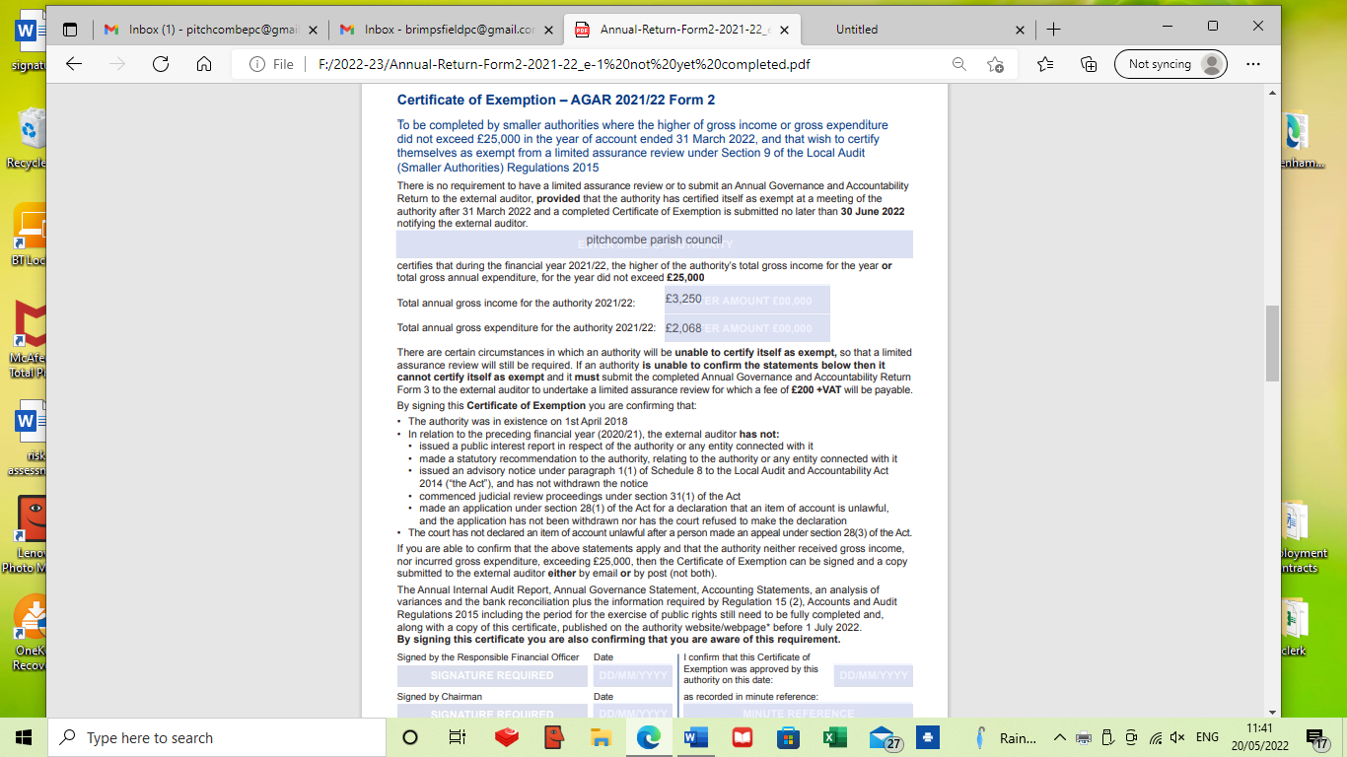

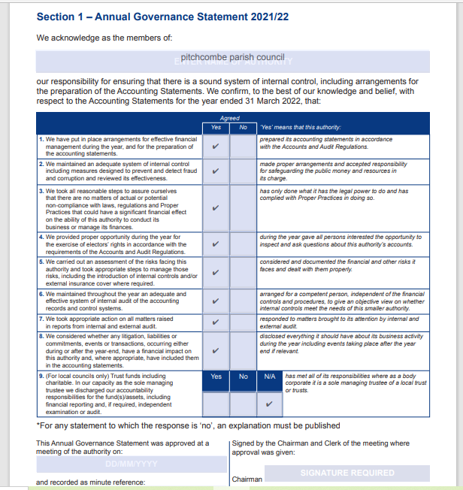

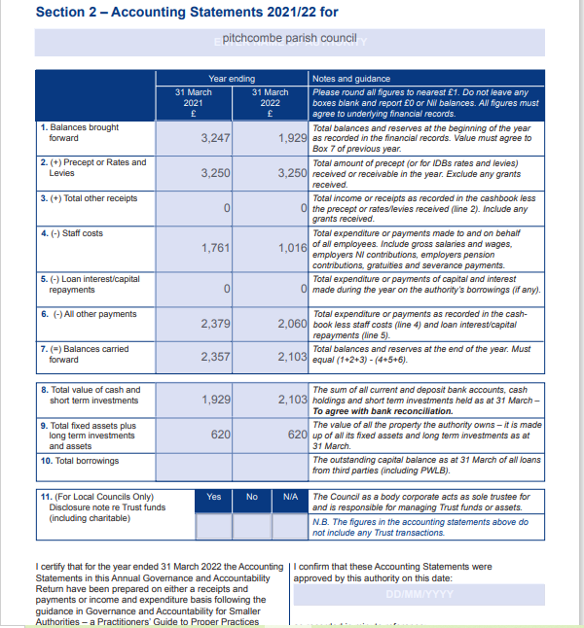

Note the preparation of the accounting statements have changed this year. They are now prepared on a payments and receipts basis



